Job Description

**Position:** Circulation Head

**Range:** T5 (Non-Exempt) (Union)

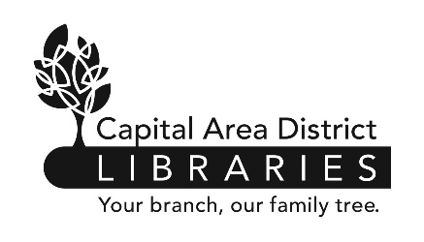 **Reports to:** Library Head

**Supervises:** Library Clerks, Library Pages

**Reviewed:** 12/07 **Revised:** 11/20

Capital Area District Library

www.cadl.org

Job Summary

Under the supervision of the Head Librarian, supervises the daily workflow in the circulation area. Recommends practices and procedures for circulation services. Trains, supervises, directs, evaluates and schedules staff. Assists in other areas of the library, providing support when workloads dictate. May provide assistance to other branches as needed.

Duties and Responsibilities

1. Responsible for the day-to-day management of the circulation department. Implements established policies and procedures.
2. Coordinates the activities of assigned personnel, assigning duties, and scheduling work hours. Assesses the quality and accuracy of staff performance, conducts scheduled evaluation, and counsels employees as necessary. Assists in the interview and selection of job applicants for the department.
3. Works at the Circulation Desk to assist patrons with their library needs. Explains library policies and procedures regarding circulation to the public. Addresses complaints from the public.
4. Keeps employees informed about library policies and procedures.
5. Supervises cash transactions including balancing the cash register, preparing reports, and making bank deposits.
6. Supervises patron registration.
7. Orders supplies and materials.
8. Insures that all machines are kept in working order.
9. Compiles patron and materials statistics.
10. Adds brief bibliographic records for on-the-fly materials and “no records” materials.
11. Manages the newspaper and magazine collection including adding item records.
12. Manages the new book collection including changing location codes and loan periods.
13. Oversees hold and interlibrary loan procedures.

*Circulation Head Job Description*

*Page 1 of 2*

*The above statements are intended to describe the general nature and level of work being performed by people assigned this classification. They are not to be construed as an exhaustive list of all job duties performed by personnel so classified.*

Job Requirements

* Possession of a High School Diploma or its equivalent.
* A minimum of two year’s progressively responsible clerical experience is required. Public library experience is preferred. Supervisory experience is preferred.
* Successful completion of a six month probationary period.
* Be physically able to perform the essential functions of the position, with or without reasonable accommodation.
* Second Language speakers desired.
* Comprehensive knowledge of office terminology, procedures and equipment and of business arithmetic and English.
* Ability to operate standard office equipment such as personal computers, copiers, calculators, and adding machines.
* Ability to make relatively complex mathematical computations rapidly and accurately.
* Ability to maintain complex records and prepare reports from such records.
* Ability to follow complex written and oral instructions.
* Ability to make decisions in accordance with established policies and procedures.
* Ability to organize and direct the work of other clerical employees.
* Ability to establish and maintain effective working relationships with co-workers and the public.
* Ability to conduct oneself with tact and courtesy.

*Circulation Head Job Description*

*Page 2 of 2*